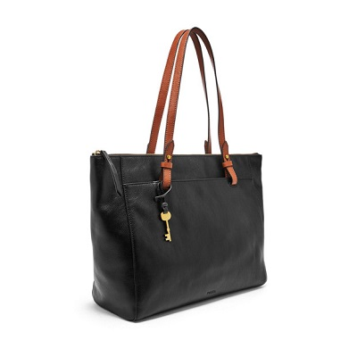

Rachel Tote

**Silhouette:** Tote With Zipper

**Tech Compatibility:** 13" Laptop

**Exterior Material:** Leather/Polyurethane Trim

**Interior Details:** 1 Zipper Pocket, 2 Slide Pockets

**Measurements:** 14"L x 4"W x 13"H

**Handles/Straps:** 2 Handles